JCTC MAT 150 Pre-Test #3 Spring 2023
Determine the vertex, y –intercept, axis of symmetry, whether the function has a maximum or minimum, the domain and range of each, and sketch:
- y = 2(x+2)² +4
- f(x) = -(x+4)² -4
- y = -x² -6x -8
- g(x) = -4x -2 + 2x²

- Among all pairs of numbers who difference is 14, find a pair whose product is as small as possible. What is the minimum product?
- The function f(x) = -x² +46x – 50 models the daily profit, f(x), in hundreds of dollars, for a company that manufactures x computers daily. How many computers should be manufactured each day to maximize profit? What is the maximum daily profit?
- A baseball plays hits a pop fly into the air. The function s(t) = -16t² +64t + 5 models the ball’s height above the ground, s(t), in feet, t seconds after it is hit. When does the baseball reach its maximum height? What is that height? After how many seconds does the baseball hit the ground?

- Determine which are polynomials:

y = 2x +3

f(x) = 2x⁻¹ +4x²

g(x) = -4x³ +3x² -2x +4

h(x) = $\frac{4}{x^{2}}$

y = 4x³ + πx

k(x) = 3x^{y}

- Sketch an example of a polynomial and two examples that are not polynomials. Describe features of each that indicate why the graph is/is not a polynomial.

- Write the equation of a polynomial that is rising on the left and right end, using the Leading Coefficient Test.

- Write the equation of a polynomial that is rising to the left, falling to the right, using the Leading Coefficient Test.
- Find the zero(s) of f(x) = 3(x+5)⁴(2x-6)²

- Using #12, indicate whether the graph is touching or crossing the x-axis at those points.

- Find the zero(s) of f(x) = 2x³ + 5x² -8x -20

- Using #14, indicate whether the graph is touching or crossing the x-axis at those points.

- Use the LCT, all intercepts and other test points to sketch f(x) = -x⁴ +x²
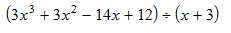
Perform the indicated division (17-19), showing all work.
17.
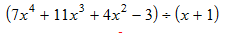
18.

- *****(4x⁴ + 6x³ +3x -1) / (2x² +1)

- Solve the equation x³ -17x +4 = 0 given that 4 is a root.

- Use the Rational Zero Theorem to list all possible rational zeros of

f(x) = 3x⁵ -2x⁴ -15x³ +10x² +12x -8

Determine all roots or zeros (22-24), showing all work.
- f(x) = x³ -2x² +26x
- 6x³ -11x² +6x -1 = 0
- x⁴ -x³ -11x² -x -12 = 0

- Find the 3rd degree polynomial function with zeros of 1 and i and satisfying f(-1) = 8

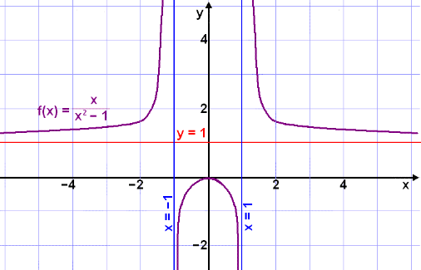
- Describe the asymptotic
behavior of f(x)

Find all asymptotes, holes and intercepts. If a graph is provided, also graph (clearly showing asymptotes, intercepts and points on each side of a vertical asymptote). Show all work.
- y = $\frac{-2x^{3}}{x^{2}+1}$

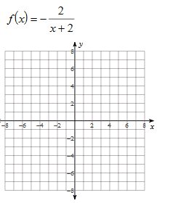

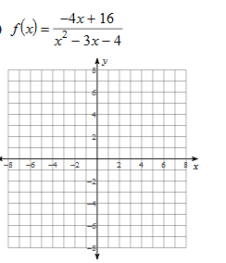

Solve for “x”, showing all work and expressing your solution set it interval notation.
30. -x² +2x > 0

31. x³ < 4x²

32. $\frac{x+5}{x-2}$ > 0

33. $\frac{x+1}{x+3}$ < 2

34. An object is propelled straight up from ground level with an initial velocity of 80 feet per second. Its height at time t is modeled by
S(t) = -16t² +80t
where the height, S(t), is measured in feet and the time, t, is measured in seconds. In which time interval will the object be more than 64 feet above the ground?

